Power Platform: Building Model-Driven Power Apps and Customizing Dynamics 365 Apps

Module 1: Customizations Lab

Student Lab Manual

Conditions and Terms of Use

Microsoft Confidential - For Internal Use Only

This training package is proprietary and confidential, and is intended only for uses described in the training materials. Content and software is provided to you under a Non-Disclosure Agreement and cannot be distributed. Copying or disclosing all or any portion of the content and/or software included in such packages is strictly prohibited.

The contents of this package are for informational and training purposes only and are provided "as is" without warranty of any kind, whether express or implied, including but not limited to the implied warranties of merchantability, fitness for a particular purpose, and non-infringement.

Training package content, including URLs and other Internet Web site references, is subject to change without notice. Because Microsoft must respond to changing market conditions, the content should not be interpreted to be a commitment on the part of Microsoft, and Microsoft cannot guarantee the accuracy of any information presented after the date of publication. Unless otherwise noted, the companies, organizations, products, domain names, e-mail addresses, logos, people, places, and events depicted herein are fictitious, and no association with any real company, organization, product, domain name, e-mail address, logo, person, place, or event is intended or should be inferred.

© Microsoft Corporation. All rights reserved.

Copyright and Trademarks

© Microsoft Corporation. All rights reserved.

Microsoft may have patents, patent applications, trademarks, copyrights, or other intellectual property rights covering subject matter in this document. Except as expressly provided in written license agreement from Microsoft, the furnishing of this document does not give you any license to these patents, trademarks, copyrights, or other intellectual property.

Complying with all applicable copyright laws is the responsibility of the user. Without limiting the rights under copyright, no part of this document may be reproduced, stored in or introduced into a retrieval system, or transmitted in any form or by any means (electronic, mechanical, photocopying, recording, or otherwise), or for any purpose, without the express written permission of Microsoft Corporation.

For more information, see Use of Microsoft Copyrighted Content at

<http://www.microsoft.com/about/legal/permissions/>

Internet Explorer, Microsoft, Microsoft Dynamics, Microsoft Dynamics logo, and Windows are either registered trademarks or trademarks of Microsoft Corporation in the United States and/or other countries. Other Microsoft products mentioned herein may be either registered trademarks or trademarks of Microsoft Corporation in the United States and/or other countries. All other trademarks are property of their respective owners.

Contents

Lab1: Use the core customization process 6

Exercise 1: Create a new Solution 7

Exercise 2: Create a new Partner Table and Columns 8

Exercise 3: Add columns to Forms and Views 10

Exercise 4: Create a model-driven app for Partner Tracking 12

Exercise 5: Functionality enhancements 15

Exercise 6: Enhance user experience 20

Exercise 7: Configure editable sub-grid for Partner Table 23

# Lab1: Use the core customization process

#### Introduction

In this lab, you will learn how to customize Microsoft Dynamics 365 through the user interface using only Out-Of-Box (OOB) functionality.

#### Objectives

After completing this lab, you will be able to:

* Implement your data model in D365 by creating new tables and columns.
* Create friendly user interfaces for users to create and consume records using forms and views.
* Enhance application and user functionality with the use of more complex columns, business rules, and custom controls.

#### Prerequisites

Have a D365 Environment available

#### Estimated time to complete this lab

20 minutes

#### Scenario

A new application needs to be created to be able to track partner relationships. This application will allow users to create and see partner records. It will also allow the ability to track notes, tag partners with specific information and relate contacts to partners.

## Exercise 1: Create a new Solution

#### Introduction

In this exercise, you will learn how to create a solution that will hold the customizations required for the partner application to be built. Proper solution management will be handled in later labs.

#### Objectives

After completing this exercise, you will be able to:

* Identify where solutions are stored in D365 environment
* Create new Solution and Publisher
* Create new components associated with a solution

#### Estimated time to complete this lab

20 minutes

#### Comments

This exercise is aimed to provide basic Application Lifecycle Management (ALM) practice when creating customizations in D365. This solution will make the process of moving customizations from one environment to another much simpler.

Task 1: Create a new Solution

1. Navigate to <https://make.powerapps.com>.
2. Choose an environment where the Partner Application will be created. You can change the environment from the **Environments** dropdown at the top of the page.

3. Navigate to Solutions area and select **+New solution**.

4. On the **Publisher** dropdown, select **+Publisher**. Provide the display name of **Demonstration** and the prefix of **demo.**Select **Save and Close**. The publisher should now be available in the **Publisher** dropdown.

5. Enter the **Display name** as **Partner Tracking Solution** and **Version** as 1.0.0.0.

## Exercise 2: Create a new Partner Table and columns

#### Objectives

After completing this exercise, you will be able to:

* Create custom tables with custom columns

#### Prerequisites

None

#### Scenario

The main record type for this application will be the Partner record. This record will help identify Partner records with the following information: their name, website, phone number, whether they are a Microsoft and/or a D365 partner, their corresponding industries of focus, and a unique Partner ID.

**Note**: Challenge yourself and try to create the previous items on your own.

Task 1: Create a new Table

1. Open the previously created solution. There should not be any components.
2. Select **+New** and choose **Table**. Provide the following details for the newly created table:
3. **Display Name**: Partner
4. **Plural**: Partners
5. **Primary** **Name Column**: Name

3. Select the checkbox for **Enable attachments** and select **Done**.

4. Create the following columns**.** Select **+New**, then select **Column.**

**Note:** Some settings may be under **Advanced Settings.**

|  |  |  |  |  |
| --- | --- | --- | --- | --- |
| **Display Name** | **Data Type** | **Required** | **Searchable** | **Comments** |
| Website | URL | Optional | Yes |  |
| Main Phone | Phone | Required | Yes |  |
| Microsoft Partner | Yes/No | Required | Yes | Make ‘No’ Default Value |
| Partner Rating | Whole number | Optional | Yes | Min=1 Max = 5 |
| Partner Number | Auto number | Optional | Yes | Auto Number Type: Custom  Format: PRT-{SEQNUM:4}-{RANDSTRING:4}  Seed Value: 1 |
| Summary | Multiple lines of text | Optional | No | Plain text |

5. Create the following two choices using the same process:

|  |  |  |  |  |  |
| --- | --- | --- | --- | --- | --- |
| **Display Name** | **Required** | **Searchable** | **Data Type** | **Options** | **Comments** |
| D365 Partner | No | Yes | Choice | None Silver Gold | Default: None |
| Industry | Yes | Yes | Choices | Professional Services  Health & Life Sciences  Public Sector  Financial Services | Default: None |

6. On the ‘Partner columns and data’ area, **select** the **+more dropdown**. Uncheck **(Select All)** and select ‘Name’ and the columns previously created.

7. Enter sample data into the below sub grid.

## Exercise 3: Add columns to Forms and Views

#### Objectives

After completing this exercise, you will be able to:

* Include the previously created columns in Forms for users to be able to create and update records
* Include columns in views for users to quickly filter through the Partner records

#### Prerequisites

Exercise 2 above

#### Scenario

After the data schema has been created, it needs to become available for users so that they can interact the data. The columns should be properly placed in a single place for data input and readability. Furthermore, users will need to be able to filter through the many records and find key information in an efficient manner.

Task 1: Add the created columns to the form

1. From the solution previously created open Partner Table definition page and, navigate to **Forms** tab.

1. Open the form type ‘Main’, search for the previously created columns, and drag and drop them into the form. Except for the Summary.
2. **A screenshot of a computer

   Description automatically generated**Create a new tab and call it “Summary”. Drag and drop the **Summary** column in the section in the newly created tab. Also, in the right menu, change the **Form field height** to **5**.
3. Drag and Drop **Partner** Number and drag on the header of the form. Once done, select **Save** and then **Back**.

Task 2: Add the created columns to a view

1. Navigate to the **Views** area on the Partner table.
2. Open the **Active Partners** view. Remove the **Created On** column from the view.
3. Drag and drop these columns into the view—Website, Main Phone, and Partner Number.
4. Once done, select **Save** and **Back**.

## Exercise 4: Create a model-driven app for Partner Tracking

#### Objectives

After completing this exercise, you will be able to:

* Create a model-driven app
* Include previously built solutions into a model-driven app
* Understand customization techniques with the Unified Interface (UCI)

#### Prerequisites

Exercise 3 above

#### Scenario

Partner Tracking will be an extra app to be supported. It will have a specific set of use cases, users, and appearance. This will reutilize the previous solution built to minimalize the complexity of customizations. It will provide a centralized location for users to identify and access the Partner Tracking application.

Task 1: Create a model-driven app

1. Navigate back to the **Partner Tracking Solution** previously created (the initial page where the **Partner Table** was created).
2. Select **Publish all customizations** to publish the metadata of the previous changes made to the forms and views.

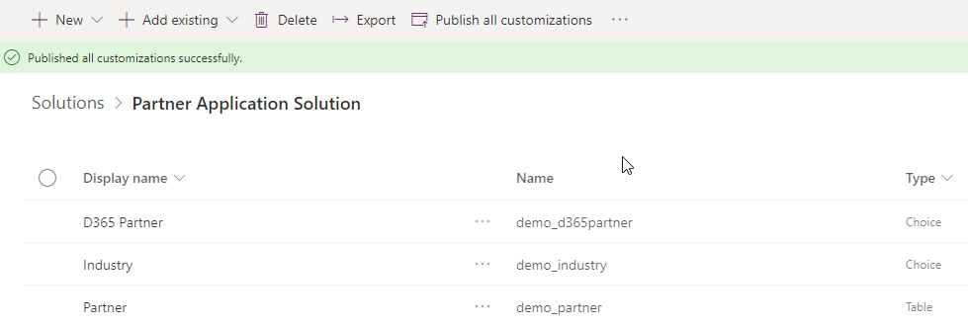

1. Go to the partner table and select the **Create an app** button from the header
2. Set the name to **Partner Tracking** and select **Create**.

1. Once the Model Driven App editor comes up, click **+ Add Page** in the top navigation bar.
2. Select **Dataverse Table** and click **Next**
3. Choose **Select existing table**
4. A screenshot of a computer

   Description automatically generatedIn the **Select one or more tables** box search for ***contact*** to find the **Contact** table and select it. Make sure **Show in Navigation** is checked
5. Click **Add** to add the Contact table to the app
6. Select **Save**, **Publish** from the top-right corner. Once it’s done publishing select **Play.**

1. Graphical user interface, text, application

   Description automatically generatedThe model driven app should load with **Contacts** and **Partners** on the Navigation.

Task 2: Verify and validate customizations

1. Select **+New** on the **Active Partners** view and populate values for the columns created, except for the Summary.
2. Graphical user interface, text, application, email

   Description automatically generatedSelect **Save.**

## Exercise 5: Functionality enhancements

#### Objectives

After completing this exercise, you will be able to:

* Create columns that rely on simple to complex calculations
* Provide client-side enhancements without code with the use of business rules

#### Prerequisites

None

#### Scenario

There can be a large amount of information that can be collected about a Partner. Not all information is needed at once; some information might be required depending on the value of others. Three new requirements have been put together. 1) A new enhancement to the partner application is to ask a Microsoft partner if they are a D365 partner. 2) Another enhancement that has been requested is to work out the date of contract renewal based on the end date of a Partner’s contract. 3) An area where end users can add notes about a particular partner. 4) An easy way to summarize the partner information in a complete sentence.

Task 1: Incorporate contract start, end, and renewal dates

1. Navigate to Make.PowerApps.com and open the solution you created earlier in the lab. Then open the Partner Table page used to create columns and create two new columns that are both **required** and of **Data Type=Date Only.** 
   1. Contract Start
   2. Contract End
2. Create a new **Date Only** column called **Start Renewal**, this time defining behavior it as a **Calculated**.
3. Select **Save and edit**. Saved a new Popup should appear to set the calculation formula.

**Note**: If popup does not appear. Select on the field created, and select ‘Edit’.

1. In Actions find the formula, **SUBTRACTMONTHS**(Whole Number, Date and Time) and within parentheses enter **1, contract**. This will find the fields that have the word ‘contract’. Choose the one that represents **Contract End**.

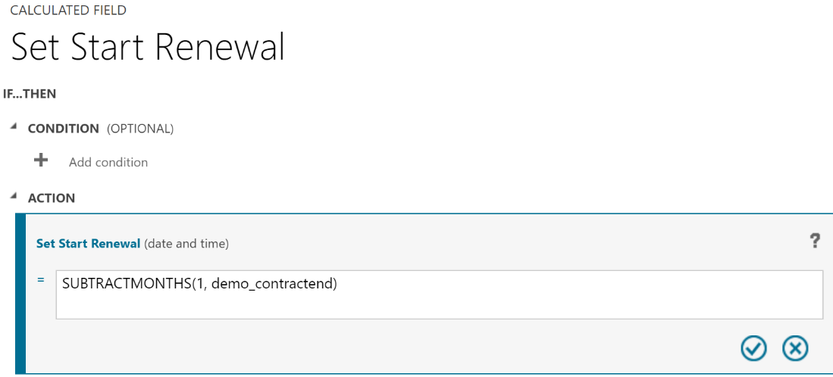

1. Select the checkmark to validate the formula. Select **Save and Close** and then select **Done**.

Task 2: Create New Section and Add Columns to Form

1. Navigate to the Partner Main Form edited earlier.
2. Select on **Components** on the left pane, select **1-Column section** under the **Layout** tab.
3. On the right pane, change the **Section Label** to **Contract Information** and **Name** to **ContractInformation**.
4. Drag and drop the three previously created **Date Only** columns into the **Contact Information** section.
5. Select **Save**, then select **Publish**, and then select **ß Back.**
6. Navigate to the **Partner Tracking Application** created earlier and refresh (Ctrl+F5) the page.
7. Create a new record and populate values for **Contract Start** and **Contract End**.
8. Click **Save.** Upon saving, **Start Renewal** should calculate appropriately.

Task 3: Hide/Show columns using business rules

1. Navigate to the **Partner Tracking** solution.
   1. Recap: <https://make.powerapps.com> > **Solutions** > **Open** **Partner Tracking** Solution
2. Open the **Partner Table**.
3. Select on the **Business Rules** section and then select **Add business rule+** from the header. The business rule editor will open.
4. Partner: New business rule 
   Business rule name 
   Is Microsoft Partner 
   Description 
   Enter a description Set the business rule name to **Is Microsoft Partner**
5. On the top right of the navigation bar, change the **Scope** to **All Forms***.*
6. Select the **Condition** box and select **Microsoft Partner** in the **Field**. This condition can be configured on the right side of the pane.
7. Mark the **Yes** checkbox in the value option. The condition should check if Microsoft Partner is set to Yes.

1. Select **Apply** to save the condition. **Note:** You may have to scroll down to see the **Apply** button.
2. A screenshot of a cell phone

   Description automatically generatedSelect the **Add(+)** sign and **Add Set visibility** to set the visibility of the D365 Partner field. This action will be placed on the path where the condition is met.
3. Configure the **Set** **Visibility** action on the right pane, setting **Visibility** to **Yes** for the **D365 Partner Column**.
4. Select **Apply** to save the action.
5. A picture containing Teams

   Description automatically generatedThe current **Business Rule** should look like this:
6. Using the same business rule, add **Set Visibility** action for the false branch of the business rule condition. The actions should hide D365 Partner.
7. Graphical user interface, application, Teams

   Description automatically generatedAfter the above modifications, the **Business Rule** should look like this:
8. Click **Save** in the command bar.
9. Click **Activate** in the command bar and **Activate** in the Process Activate Confirmation window.
10. Test the business rule for expected behavior in the Partner Tracking Application. Setting No to Microsoft Partner should hide D365 Partner field. (Ctrl+F5 to ensure latest version).

Task 4: Add Timeline Control

1. Graphical user interface, application

   Description automatically generatedNavigate to the **Partner** and open the main form using the form designer. On the left pane select **Tree View**, search for the **General** section and select the general section. Once selected, change the **Columns** property on the right pane from one column to **two Columns.** This will allow to use empty space appropriately.
2. Navigate to the **Components** area on the left pane, search for **Timeline** and add the Timeline component into the section.
3. **Save** and **Publish** the form. Test the timeline in the Partner Tracking Application. Add a new note to the timeline.

Task 5: Add Modern Command

1. Go to **make.powerapps.com**
2. In the top right, check if the correct environment is selected.
3. A screenshot of a computer

   Description automatically generatedIn the left menu, click on **Apps** and then change the filter to **All**
4. **A screenshot of a computer

   Description automatically generated**Look for your app and **Edit** it
5. A screenshot of a computer

   Description automatically generatedFrom there, go to **Pages** if you’re not already there and look for the **Partner** table. Click on the 3 dots (…) and go to **Edit command bar**
6. Choose **Main Form**
7. Select **+ New** -> **Command**A screenshot of a computer

   Description automatically generated.
8. Drag the newly created command to the position **after the +New button**.
9. A screenshot of a computer

   Description automatically generatedChange the **label** of the button to Summarize, use the **ActivateQuote** **icon**, and the action should be **Run formula**. The other fields can be left as they are.
10. Click on **Open formula**
11. Make a Power FX formula that states the following:  
    **<Name>** is active in the industry <**Industry>**. They are [a / not a] <**Microsoft Partner>** [with a Partner Rating of <**Partner Rating> /** without a Partner Rating**]**. They can be reached at <**Main Phone>**

Make use of Patch(), If(), and string concatenations. Please use the following formula if you’re stuck:

Patch(Partners, Self.Selected.Item, {'Summary': Self.Selected.Item.Name & " is active in the industry " & Self.Selected.Item.Industry & ". They are " & If(Self.Selected.Item.'Microsoft Partner' = true, If(Self.Selected.Item.'Partner Rating' = Blank(), "a Microsoft Partner without a Partner Rating.", "a Microsoft Partner with a Partner Rating of " & Self.Selected.Item.'Partner Rating' & "."), "not a Microsoft Partner.") & " They can be reached at " & Self.Selected.Item.'Main Phone' & "."})

1. Once done, **Save and Publish** the changes and test it by going to the record and pressing the on the command button you just created.
2. Depending on what details you filled in on the record, the result should look something like this:

## Exercise 6: Enhance user experience

#### Objectives

After completing this exercise, you will be able to:

* Make use of custom controls to enhance users’ data entry and readability
* Learn techniques to reduce data entry errors caused by users

#### Prerequisites

None

#### Scenario

Although the Partner Tracking Application meets its core business needs at the moment, it is plain. Users would prefer for some of the data values to be more pleasant to the eye and improve the data entering process, whether they are on a desktop or on a mobile device.

Task 1: Make Choice Columns Easier to Use

1. Navigate to the Partner table main form designer. Select on **Microsoft Partner** column and select on **+Component** from the field components on the right pane. Select the **Toggle** control and select **Done**.
2. Repeat the same process of adding a control for **D365 Partner** column, but this time add the **Option Set** control.

1. On the form designer, select **Save** and **Publish** from the header.

(Optional) Task 2: Make the Rating Column Easier to Use with a custom PCF Control

1. 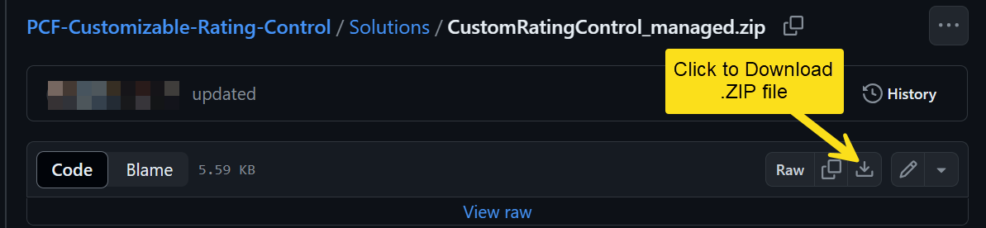Install the solution file provided by your instructor, or download the **unmanaged** solution from [GitHub here](https://github.com/jeevarajan04/PCF-Customizable-Rating-Control/blob/master/Solutions/CustomRatingControl_managed.zip).
2. Navigate to the **Partner** table main form designer. Select the **Partner Rating** column and select on **+Component** from the field components on the right pane. Select the **CRMIndian_RatingControl** control. Enter these values in the **Static Values** in the dialog box.
   1. **IconStyle**: fas fa-star
   2. **NumberOfIcons**: 5
   3. **UnselectedColor**: #E8E8E8
   4. **SelectedColor**: #2944EC

## Exercise 7: Configure editable subgrid for Partner Table

#### Objectives

After completing this exercise, you will be able to:

* Configure editable grid functionality within the Partner views

#### Prerequisites

None

#### Scenario

Users often make quick edits to several records. Currently, the only way to do it be by opening each record, editing the column that needs to be updated, saving the updates, and then navigating to a new record. You will enhance this process by giving users the ability to make changes directly from the view.

Task 1: Enable the Editable Grid control on the Partner Table

1. Navigate to the Partner Tracking Solution and on the header select on the **Switch to classic** option from the three dots.

1. Double select on the Partner table and select on the **Controls** tab. Select on **Add Control** > **Editable Grid > Add**.

1. Select the **Web** radio button and select **Save.** Select **Publish**.

Task 2: View the Active Partners view with the Editable Grid control

1. Navigate to the **Partner Tracking Application** and refresh the page.
2. Navigate to the **Active Partners** view. Notice that the **Active Partners** view now has all the data being displayed in an editable grid.
3. Select a cell on the row and enter a value. Select on **Save (Small save button on upper right-hand corner of grid)** to save your changes.

